Project Design Phase-**||**

**Technical Architecture**

|  |  |
| --- | --- |
| TEAM LEAD | S. SATHISH |
| NM ID | D3AB4E60998F2BBA802428A0FF7D9B00 |
| PROJECT NAME | Creating a landing page in HubSpot |

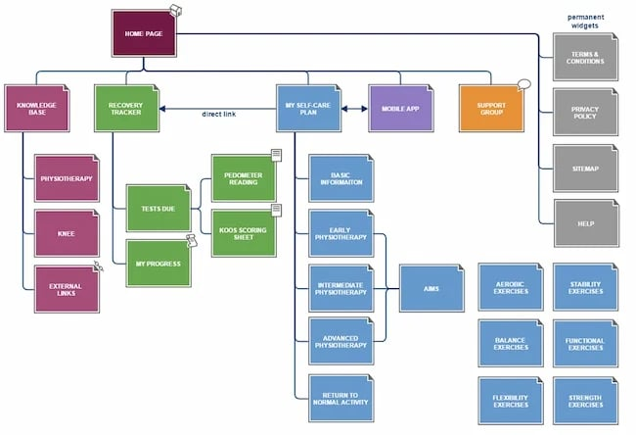

Creating a landing page in HubSpot typically involves a combination of tools and elements provided by the HubSpot platform. Here's a simplified technology architecture for creating a landing page in HubSpot:

1. **HubSpot Account:** You need an active HubSpot account to get started.
2. **Content Management System (CMS):** HubSpot provides a built-in CMS for creating and managing web pages, including landing pages. You'll use the CMS to design and publish your landing page.
3. **Template or Theme:** HubSpot offers pre-designed templates and themes that you can customize to create your landing page. You can also create your own templates from scratch or use HTML and CSS to design custom landing pages.
4. **Drag-and-Drop Editor:** HubSpot's drag-and-drop editor simplifies the design process. You can add and arrange elements such as forms, images, text, and videos on your landing page.
5. **Form Builder:** HubSpot's form builder allows you to create forms to collect user data on your landing page. You can integrate these forms with your contact database.
6. **Lead Capture:** Use HubSpot's lead capture tools to gather and store information about your leads or visitors. This data can be integrated with your CRM for lead nurturing.
7. **Responsive Design:** Ensure your landing page is responsive to different devices (desktop, tablet, and mobile) using HubSpot's responsive design tools.
8. **SEO Optimization:** Optimize your landing page for search engines by leveraging HubSpot's SEO tools, including meta tags, headers, and content analysis.
9. **A/B Testing:** HubSpot provides tools for A/B testing your landing page elements to optimize conversion rates.
10. **Analytics and Reporting:** Track the performance of your landing page with built-in analytics and reporting tools to understand visitor behavior and conversion rates.
11. **Integration:** Integrate HubSpot with other tools and platforms as needed, such as CRM, email marketing, or social media platforms, to streamline your marketing efforts.
12. **Security:** HubSpot ensures the security of your landing pages, including SSL certificates for data encryption.
13. **Hosting:** HubSpot hosts your landing pages, so you don't need to worry about server setup or maintenance.
14. **Domain Mapping:** If you have your own domain, you can map it to your HubSpot landing page for a branded experience.
15. **Content Delivery Network (CDN):** HubSpot utilizes CDNs to ensure fast page loading times and global availability.

Remember that HubSpot's platform provides an all-in-one solution for creating, hosting, and managing landing pages. The specific technology architecture may vary based on your customization and integration needs, but these are the core elements involved in creating a landing page in HubSpot.